Online Orders
Data Model
Scenario 1:

1. Entity–relationship schemas
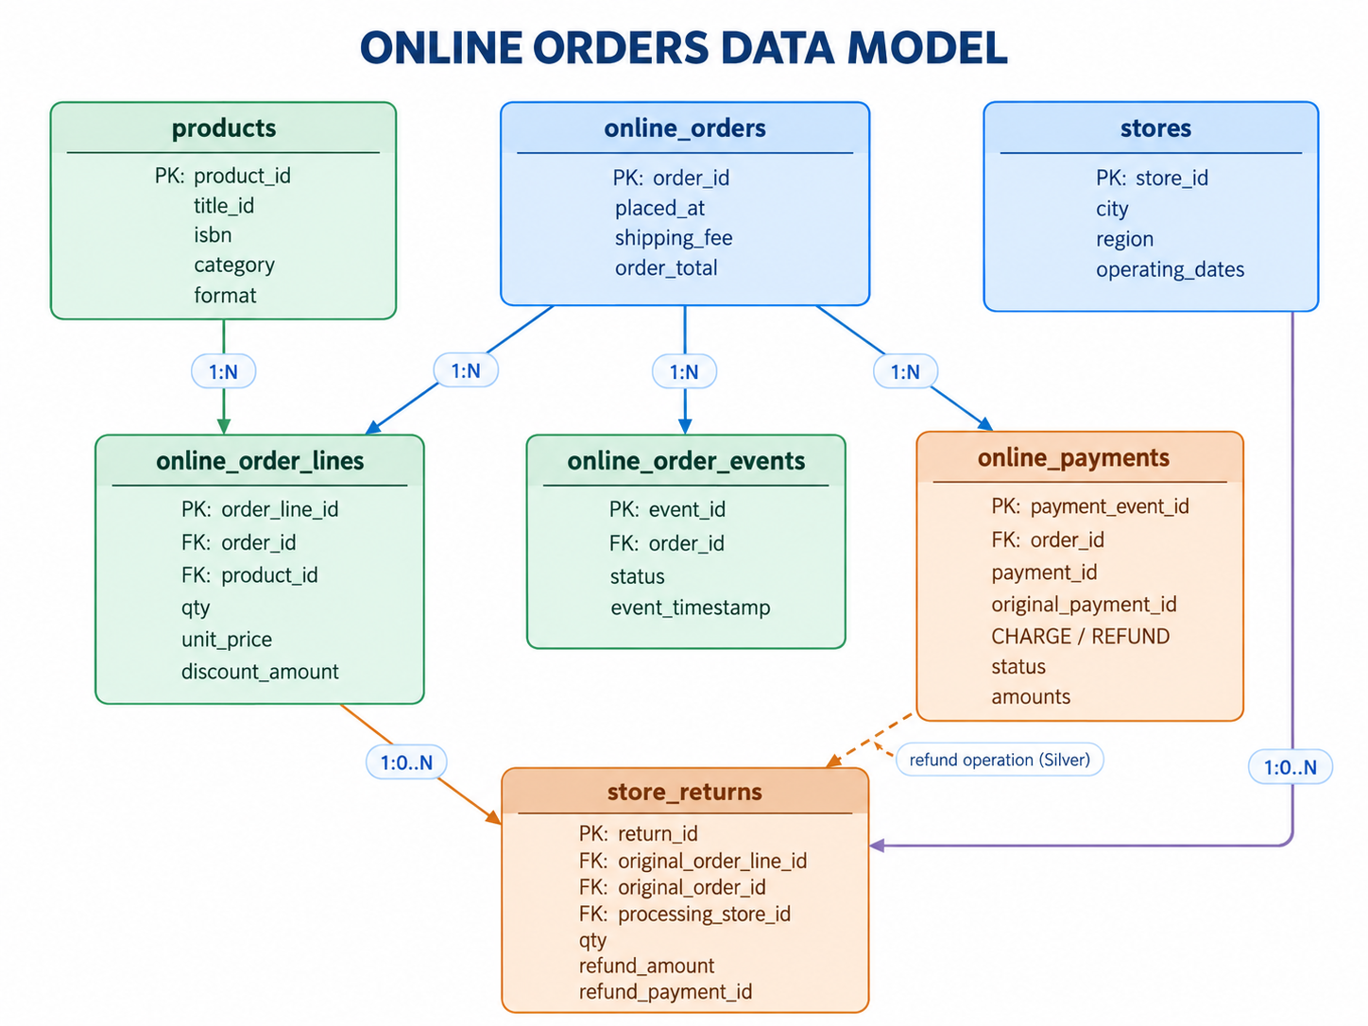

2. Relationship and cardinality register
Parent | Child | Join / validation
online_orders | online_order_lines | order_id
online_orders | online_order_events | order_id
online_orders | online_payments | order_id
products | online_order_lines | product_id
online_order_lines | store_returns | original_order_line_id
stores | store_returns | processing_store_id
online_orders | store_returns | original_order_id; must equal line’s order_id
payment operation | store_returns | refund_payment_id → consolidated refund payment_id in Silver

3. Source data dictionary — commercial records

3.1 online_orders.csv
Grain One row per order. Authoritative original checkout header; status is deliberately excluded.
Column | Key / type | Use
order_id | PK · string | Stable identity of one online checkout; referenced by lines, events, payments and returns.
placed_at | timestamp | Order-placement event time, used for placement cohorts.
shipping_fee | decimal | Original delivery fee at order level, not repeated per product line.
order_total | decimal | Original checkout payable = discounted product line values + shipping_fee.

3.2 online_order_lines.csv
Grain One row per purchased product line. Allows multiple different products on an order.
Column | Key / type | Use
order_line_id | PK · string | Stable identifier used to link partial product returns.
order_id | FK · string | Links to online_orders.order_id.
product_id | FK · string | Links to products.product_id; ISBN is never required to join sales.
quantity | integer | Purchased unit count; positive for original order lines.
unit_price | Decimal | Original VAT-inclusive unit price, fixed at checkout.
discount_amount | decimal | Total discount for this line, not a per-unit discount.

Silver derived line amount = quantity × unit_price − discount_amount; do not duplicate shipping_fee per line.
A later catalogue price update must never rewrite the original price line.

3.3 online_order_events.csv
Grain One distinct order-status event; repeated source exports may contain the same event_id again.
Column | Key / type | Use
event_id | PK · string | Source-issued stable ID of one status event; used for idempotent deduplication.
order_id | FK · string | Links event to the order.
status | enum · string | PLACED, PAID, READY_FOR_DELIVERY, SHIPPED, DELIVERED, CANCELLED.
event_timestamp | timestamp | Business event time; distinct from file arrival / ingestion time.

4. Source data dictionary — financial events and returns

4.1 online_payments.csv
Grain One payment-operation status event. The same payment_id may appear in multiple event rows.
Column | Key / type | Use
payment_event_id | PK · string | Stable identity of this event: PENDING, SUCCEEDED or FAILED.
payment_id | operation ID | Stable charge/refund operation ID, repeated as its status progresses.
original_payment_id | nullable reference | For REFUND: identity of original successful CHARGE operation, not its event ID.
order_id | FK · string | Links charge/refund operation to order.
event_type | enum | CHARGE or REFUND.
status | enum | PENDING, SUCCEEDED or FAILED.
product_amount | Decimal | Product portion of the operation, after line discounts.
shipping_amount | decimal | Shipping portion; normally zero on post-delivery product returns.
amount | decimal | Total positive absolute operation amount; equals product + shipping amount.
refund_reason | nullable enum | For refunds: ORDER_CANCELLATION or STORE_RETURN.
timestamp | timestamp | Timestamp when this payment status event happened.

4.2 store_returns.csv
Grain One requested/processed return of an original online order line at a physical store.
Column | Key / type | Use
return_id | PK · string | Stable identity of the physical return line; a pending update can retain this ID.
original_order_id | FK · string | Original online order, validated against the referenced order line.
original_order_line_id | FK · string | Purchased line being returned; required to validate quantity/price.
processing_store_id | FK · string | Physical store that handled the goods; not financial owner.
returned_quantity | integer | Units accepted / being evaluated for return.
refund_amount | decimal | Expected amount based on the original amount paid for the units.
return_status | enum | PENDING, COMPLETED or REJECTED.
returned_at | timestamp | Time return is presented / processed; separate from refund success time.
refund_payment_id | nullable reference | Refund operation ID; links to one consolidated REFUND in Silver.

5. Shared reference data and simplified fulfillment

5.1 products.csv
Grain One sellable SKU per product_id; books and non-books share the same identifier scheme.
Column | Key / type | Use
product_id | PK · string | Referenced by online_order_lines.
title_id | nullable string | Common work/title across paperback/hardcover editions.
title | string | Book title or general product name.
category | string | Books, stationery, board games, gifts, etc.
format | nullable string | Paperback/hardcover where applicable.
isbn | nullable string | Book-specific edition attribute; stored as a string.
catalogue_price | decimal(12,2) | Master snapshot price for reference, not for repricing historical transactions.

5.2 stores.csv
Grain One physical store per store_id, with operating-calendar data needed separately for store KPIs.
Column | Key / type | Use
store_id | PK · string | Referenced by store_returns.processing_store_id.
store_name | string | Store display name.
city | string | Processing location.
region | string | Optional current grouping; historical reorganisation belongs to Scenario 2.
opening_date | date | Open-day calendars / reporting eligibility.
status | string | Active, renovation or closed snapshot; detailed open days can be supplied separately.

5.3 Central warehouse: a fixed business assumption
WH001 — central warehouse / Scenario 1
All online orders are fulfilled from WH001. No order_id → physical selling store linkage is created.
No warehouses.csv, warehouse_inventory.csv or online_fulfillments.csv is needed in this scenario. If future warehouse-performance KPIs are approved, add logistics sources as a separate phase.

5.4 Data joins we deliberately do NOT create
Incorrect linkage | Reason to avoid
online_orders.store_id | No selling store owns an online order; financial owner is ONLINE.
products.isbn → order lines | Non-book SKUs lack ISBN, and a book’s formats need separate product_id.
store_returns → raw online_payments.payment_id | payment_id repeats across payment status events; join to a consolidated Silver operation.
online_order_events → online_order_lines directly on order_id when summing money | Creates join multiplication; derive money at independent grains first.

6. Financial derivation and status dependencies

6.1 Allowed order transitions
From | Allowed next status | Business effect
PLACED | PAID or CANCELLED | No recognized sale until CHARGE / SUCCEEDED.
PAID | READY_FOR_DELIVERY or CANCELLED | Recognized sale exists; paid cancellation initiates full refund.
READY_FOR_DELIVERY | SHIPPED or CANCELLED | Still cancellable; refund required if paid.
SHIPPED | DELIVERED | Cancellation forbidden; no new revenue at shipment.
DELIVERED | No additional online status | Eligible product returns occur only in a physical store, outside order lifecycle.

6.2 Revenue source of truth
Financial event | Online revenue effect | Supporting source data
CHARGE / PENDING or FAILED | 0 | Payment event is retained for audit.
CHARGE / SUCCEEDED | + product_amount + shipping_amount once | Operation confirmed; derive line product sales from order_lines at success date.
CANCELLED (order event) | 0 at cancellation event | May initiate refund; no automatic subtraction.
REFUND / PENDING or FAILED | 0 | Refund not financially completed.
REFUND / SUCCEEDED | − product_amount − shipping_amount once | ORDER_CANCELLATION or completed STORE_RETURN.
SHIPPED / DELIVERED / physical return | 0 until related successful refund | Do not recognize revenue twice for status/return events.

7. Layers

7.1 Medallion role by layer
Layer | Logical outputs | Responsibilities
Bronze | bronze_online_orders, _lines, _events, _payments, _store_returns, _products, _stores | Ingest incremental CSV snapshots/exports; preserve original files and event IDs; append source_file, ingestion_ts, batch_id.
Silver | silver_order_header; silver_order_lines; silver_order_state; silver_payment_operations; silver_validated_return_lines; silver_products; silver_stores; dq_quarantine | Deduplicate by event IDs, order by business event timestamps, reconstruct final operation state; verify references, quantity limits, charge/refund amounts and transition legality.
Gold | fact_sale_line; fact_refund_line; fact_payment_operation (audit/fee split); dim_product; dim_store; dim_channel; daily / monthly KPI aggregates | Recognize one product sale per paid order line, one financial adjustment per successful refund, and one shipping amount per successful payment operation; never join raw N-side tables when aggregating.
s

